BIRTLES, FRANCIS EDWIN (1881-1941)

Was born on 7 November 1881 at Fitzroy, Victoria, son of David Birtles, a bootmaker from Macclesfield, England, and his wife Sarah Jane, née Bartlett. He was educated at South Wandin State School, and at 15 joined the merchant navy as an apprentice. In 1899 he jumped ship at Cape Town, South Africa, and tried to enlist with Australian militia, but was attached to the Field Intelligence Department as part of a troop of irregular mounted infantry until May 1902. He returned briefly to Australia, then joined the constabulary in the Transvaal as a mounted police officer. His experiences there equipped him with bushcraft skills in a semi-arid environment and he undertook several cycling and photographic excursions; his police service ended when he contracted blackwater fever.

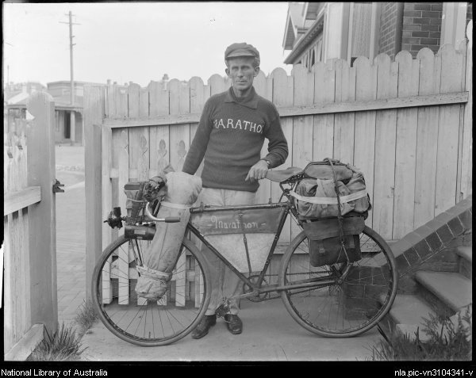
Birtles disembarked at Fremantle, Western Australia, and on 26 December 1905 left to cycle to Melbourne, an achievement which attracted widespread attention. After brief employment as a lithographic artist, in 1907-08 he cycled to Sydney and then, via Brisbane, Normanton, Darwin, Alice Springs and Adelaide back to Sydney, where he was thereafter based. In 1909 he published the story of his feat, Lonely Lands, which he illustrated with his own photographs.
That year he set a new cycling record for the Fremantle to Sydney continental crossing, then in 1910-11 rode around Australia. In 1911 he was accompanied from Sydney to Darwin by R. Primmer, cameraman for the Gaumont Co.: Across Australia was released next year. Birtles had continued on to Broome and Perth, then lowered his record by riding from Fremantle to Sydney in thirty-one days. By 1912 he had cycled around Australia twice and had crossed the continent seven times.
