Dux bicycle ridden around Australia by
Donald Mackay, 1899

Statement of significance
In 1899 Donald Mackay, became the third person to cycle around the continent after Arthur Richardson and Alex White. Mackay set a new 'Around Australia Cycling Record' of 240 days 7 hours and 30 minutes. He pedaled this Dux bicycle, 11 000 miles (17 700 km) through scarcely known areas north through Queensland, across the Northern Territory, down the west coast of the continent, across the Nullarbor Plain, then up the eastern coast. Mackay broke Richardson's record by three days.
Mackay's ride represents a vital and largely overlooked aspect of Australia's transport history. It was the last of a plethora of long distance cycling trips in Australia between 1897 and 1900 to prove the suitability and utility of the bicycle as a means of rural and outback transport.

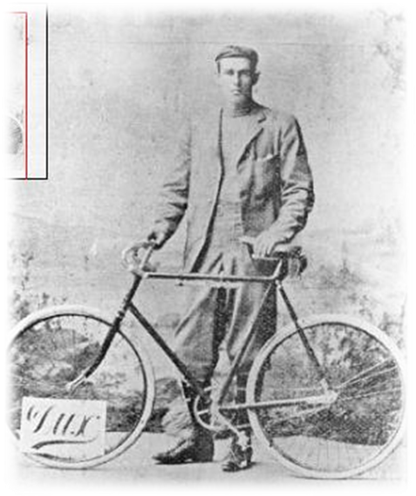
Donald Mackay

The bicycling boom in Australia took off in the 1880s with Melbourne becoming the country's cycling centre. The safety bicycle was introduced in Australia in the early 1890s and was found to be the ideal form of personal transportation in the inland areas of the continent. It was argued that as the landscape was flat and offered little in the way of obstructions, such as rivers and lakes and the vegetation was sparse the bicycle was an excellent mode of transport. Furthermore, unlike a horse or camel a bicycle ate and drank nothing, could travel 3 times faster and carry the rider plus much luggage. The bicycle also required little maintenance, most of which could be done by the rider with minimum equipment and experience.
Margaret Simpson, August 2006
Acting Curator, Science & Industry
Description
Bicycle, 'The Dux', metal / leather, made by the Dux Cycle Company, Melbourne, Victoria, 1899, ridden around Australia by Donald Mackay, 1900
The bicycle is made of up of a tubular metal frame, a rear wheel chain drive and an adjustable leather seat on springs. The spokes are tangential and there are no longer any tyres on the wheels. The iron pedals have toe clips attached and a there is a lamp bracket at the front. The bike is painted black.
Production notes
Mackay rode this Dux bicycle which was made especially for him in Melbourne at the Dux Cycle Company factory and shipped by steamer to Brisbane where the ride began on 29 July 1899. When stripped down the bicycle weighed 29 lbs (13.1 kg), as it was especially strengthened to carry Mackay's weight of 13 stone (82 kg) plus his gear which gave a total weight of 17 stone (108 kg). The Dux was fitted with Dunlop multiflex tyres.
The Dux Cycle Company was said to be one of Australia's largest bicycle manufacturers and importers at the time and was established in about 1895. Two years later the firm opened a large factory and showroom at 300-302 Little Collins Street, Melbourne, employing a staff of 150. In 1900 it was reported that the materials for the Dux bicycles were constructed of the 'best obtainable from all parts of the world' and the 'finish and designing compare most favourably with the finest examples of the old-world cycle manufacturer's art.' Furthermore, 'the Dux is constructed upon scientific principles, so that each part of the frame is either in tension or compression, thus ensuring an equal distribution of the rider's weight, and a proportionate strain over the whole of the frame'.
By 1900 it was claimed that over 4000 Dux bicycles were in use throughout the Australian colonies. The standard colours were black and yellow but the purchaser could choose any colour of enamel. The handle bars, lugs and other bright parts were nickel-plated copper. The wheels were fitted with Westwood rims, the spokes of which were of double-butted high tensioned steel arranged tangentially. The wheel hubs were wide, giving maximum space between the bearings so adding to their strength. They were dust and oil proof with especially hardened steel cones shaped from a solid piece of metal. Ladies' bicycles made by Dux were fitted with celluloid gear cases and corded silk dress guards.
History notes
Donald Mackay was born in 1870 at Yass, NSW, the son of Alexander Mackay, owner of Wallenbeen station and his wife Annie nee Mackenzie, both Scottish born. Donald was educated at Wallenbeen Public School and at Oaklands School, Mittagong, NSW. He left school at 17 and worked as an engineering apprentice at Waugh and Josephson's in Sydney. City life was unappealing to him and he returned to Wallenbeen and worked as a jackaroo. Donald's father died in 1890 leaving him a small fortune which he used to travel extensively throughout the world. He later tried prospecting for gold in western New South Wales where he came in contact with the bicycle as a means of inland transport. He used one to travel to various places including Milparinka, Tibooburra and Broken Hill, as well as Adelaide and Melbourne.
By the 1890s suppliers of bicycles could not keep up with the demand for popular maker. Manufacturers of frames, tyres and other fittings were keen to prove the superiority of their products and sponsored bicycling racing and racers. When the spate of endurance trips appeared in the mid to late 1890s, manufacturers were approached for financial assistance for using and advertising their products. However, the cycling industry was not always forthcoming and usually only agreed to reimburse or retrospectively sponsor unknown amateur cyclists such as Mackay if, and when, they completed their rides.
In 1899 Mackay heard about Arthur Richardson's proposed attempt to ride around Australia on a bicycle and began planning his own trip. Richardson had already achieved notoriety in 1896 when he was the first to ride west to east across the continent over the Nullarbor Plain. Mackay arranged to ride with Frank White, another well known overland rider, who had cycled around Australia from Perth to Rockhampton and back in 5 months. They were to start in Melbourne and travel anti-clockwise via Queensland, round and down to Perth, and then back to Melbourne. Richardson, who had started about a month before them, had travelled north from Perth in a clockwise direction.
At the last moment Mackay pulled out of the trip due to mining commitments and Frank White teamed up with his brother, Alex, and started the ride from Melbourne on 30 June 1899. Mackay managed to curtail his mining activities and joined the party in Brisbane. The three riders set out from Brisbane on 30 July 1899.
They reached Darwin on the 20 October after nearly perishing in the desert outside Powell Creek. Alex contracted a persistent case of dysentery and this slowed the progress of the party. They then met Richardson travelling in the opposite direction and were able to swap notes about the conditions they could expect along the way. Unfortunately an expected shipment of tyres and inner tubes had not arrived in Darwin and after an unsuccessful search of the town the cyclists proceeded on their journey with their already fraying tyres. To remedy this situation they cut untanned calf hides into strips and wrapped it around the tyres with lashings of rubber solution. This seemed to work quite successfully but outside Darwin Frank White's bicycle suffered irreparable damage to the pedal crank and he had to withdraw from the expedition.
The two remaining cyclists, Mackay and Alex White, arrived in Perth on 5 February 1900. Two days before their arrival Arthur Richardson arrived in Perth becoming the first person to circumnavigate the country by bicycle. Richardson had completed his ride in 243 days which meant that Mackay had to pedal from Perth to Brisbane in under 50 days to better this time.
Donald Mackay arrived at the Brisbane GPO at 5.15 pm on 25 March 1900 and set a new around Australia record of 240 days 7 hours and 30 minutes. In the process he also set new records for the Perth to Sydney and Perth to Brisbane legs.
Mackay financed the trip himself but was presented with two trophies at its completion. After his ride Mackay referred to his Dux bicycle as the "best little wheel I ever rode" and "although I humped it over rocks, through great swamps, and crashed into stumps and logs on a thousand occasions it stood up every time and never needed the slightest repair".
During the ride Mackay carried two water cans, attached to the bicycle weighing about 15 lbs (7 kg) which were in fact a failure, a revolver, ammunition, a set of tools and bicycle parts (that were never needed), a camera, a waterproof cloak, diary, time book and food bag. During the trip he wore out two pairs of cycle pants and four pairs of cycle of shoes, all of which had extra heavy soles.

